Tribal Portal – Open Dump Module

User’s Guide

  

Last Revised:

March 4, 2019



[www.open-environment.org](http://www.open-environment.org)

Tables of Contents

1 Introduction 3

2 Using the Open Dump Module 4

2.1 Getting Started 4

2.2 Sites 6

2.2.1 Sites Master List 6

2.2.2 Adding / Editing a Site 8

2.3 Assessments 9

2.3.1 Assessments List 9

2.3.2 Assessment Details 9

2.3.3 Waste Contents 14

2.3.4 Open Dump Survey Form 15

2.4 Cleanup Estimation Modeling and Actual Cleanup Projects 16

2.4.1 Cleanup Estimate Modeling 16

2.4.2 Actual Cleanup Projects 21

2.5 Importing Data 23

3 Administering the Open Dump Module 25

3.1 Approving Access Requests 25

3.2 Reference Data 27

# Introduction

Open Dump Data Management is a module of the Tribal Services Portal, and allows tribes to manage open dumps. Some high-level features of the Open Dump Module are:

* **Site Management:** Maintain a list of Open Dump sites. From a data management perspective, integrate these dump sites with other site managed by the tribes, and linking with one or more land owners.
* **Site Assessments:** Keep track of a history of assessments conducted at each open dump site, including the ability to attach files or photos for each assessment.
* **Site Cleanup Estimation Modeling:** by inputting a set of characteristics of the open dump site (including proximity factors, waste contents, disposal distance), the system will calculate estimated cleanup costs, based on EPA’s Illegal Dumping Economic Assessment (IDEA) model [(link)](https://nepis.epa.gov/Exe/ZyNET.exe/P100A9QS.TXT?ZyActionD=ZyDocument&Client=EPA&Index=2000+Thru+2005&Docs=&Query=&Time=&EndTime=&SearchMethod=1&TocRestrict=n&Toc=&TocEntry=&QField=&QFieldYear=&QFieldMonth=&QFieldDay=&IntQFieldOp=0&ExtQFieldOp=0&XmlQuery=&File=D%3A%5Czyfiles%5CIndex%20Data%5C00thru05%5CTxt%5C00000027%5CP100A9QS.txt&User=ANONYMOUS&Password=anonymous&SortMethod=h%7C-&MaximumDocuments=1&FuzzyDegree=0&ImageQuality=r75g8/r75g8/x150y150g16/i425&Display=hpfr&DefSeekPage=x&SearchBack=ZyActionL&Back=ZyActionS&BackDesc=Results%20page&MaximumPages=1&ZyEntry=1&SeekPage=x&ZyPURL)
* **Track Actual Cleanup Projects:** Track actual cleanup projects and associated costs

# Using the Open Dump Module

## Getting Started

**Register**

To begin using the Open Dump Module, first create a Tribal Portal account:

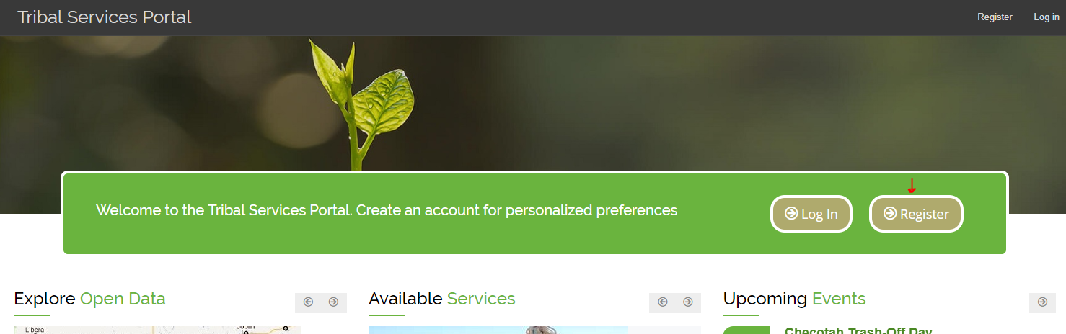

Click on the Register link on the Tribal Portal home page.

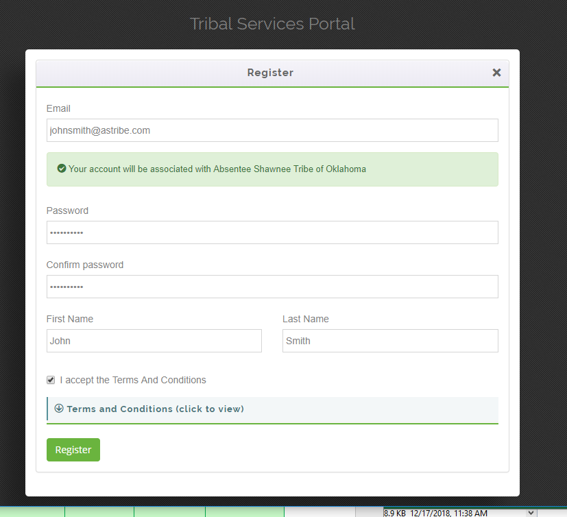

Enter in your email address and provide a password. The system will send you a verification email that you must click to verify your account.

**Get Granted Access to the Open Dump Module**

When you log into the Tribal Portal for the first time, you will not yet have access to the Open Dump module. On the Dashboard you will see the following warning:

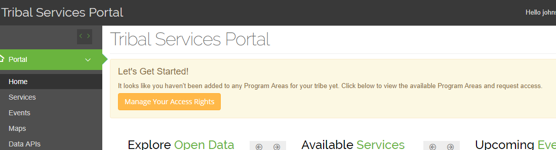

**Manage Your Access Rights**

Click the **Manage Your Access Rights** button and then the button for the Open Dump Module.

An Administrator will receive a notification of your request and will approve or reject your access rights request.

**After Gaining Access to the Open Dump Module**

After you have been granted rights to the Open Dump module, when you log into the Tribal Service Portal, you will see the Open Dump menu options on the left, as shown here:

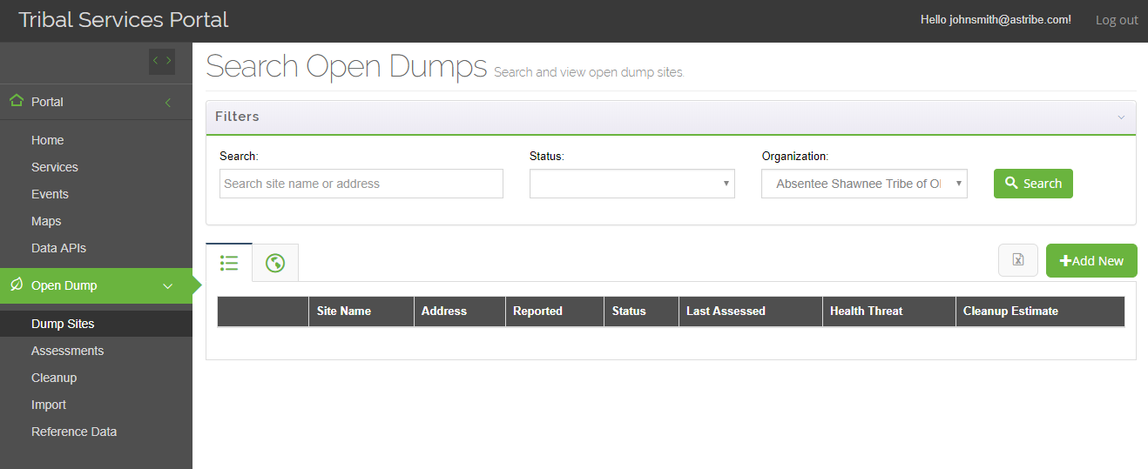

**Open Dump Module – Menu Items**

## Sites

### Sites Master List

To manage your open dump sites, click on the  left menu option.

**Search Options:** This screen will provide the following searching options:

* **Free-text search textbox:** will allow the user to search sites by Site Name or Street Address.
* **Organization Filter:** If a user has been granted Open Dump rights to more than one tribal organization, then the Organization drop-down will appear and allow the person to filter based on organization.
* **Site Status**

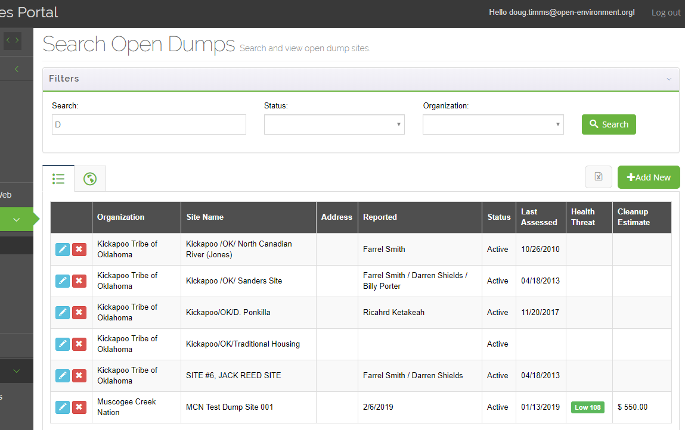

**Search Dumps – List View**

A listing of sites matching your search criteria will be displayed. The system lists the site, latest site status, last assessment date, most recent Health Threat score (if any), and cleanup estimate (based on most recent assessment).

Click the  button to add a new site, or click on the  button to edit an existing site.

Click the  button to export the site list to Excel.

Click the map tab  to view the sites on a map.

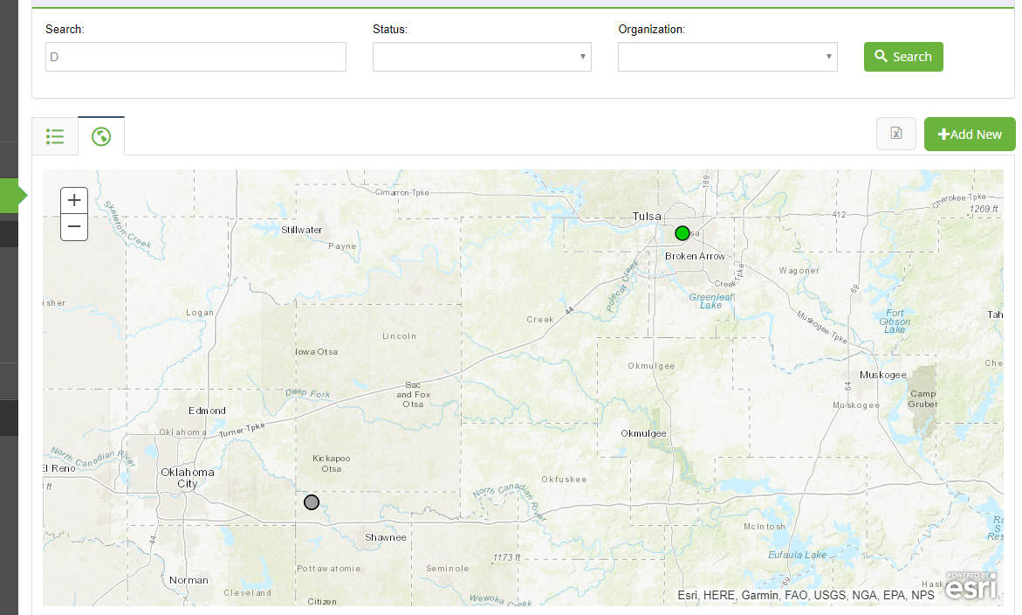

**Search Dumps – Map View**

As you can see in the picture above, the sites are color-coded. They are color-coded according to the site’s Health Threat Score, with grey meaning that the site has no health threat score calculated yet.

### Adding / Editing a Site

When adding a site, general site information is contained in the “PreField” tab, as shown here:

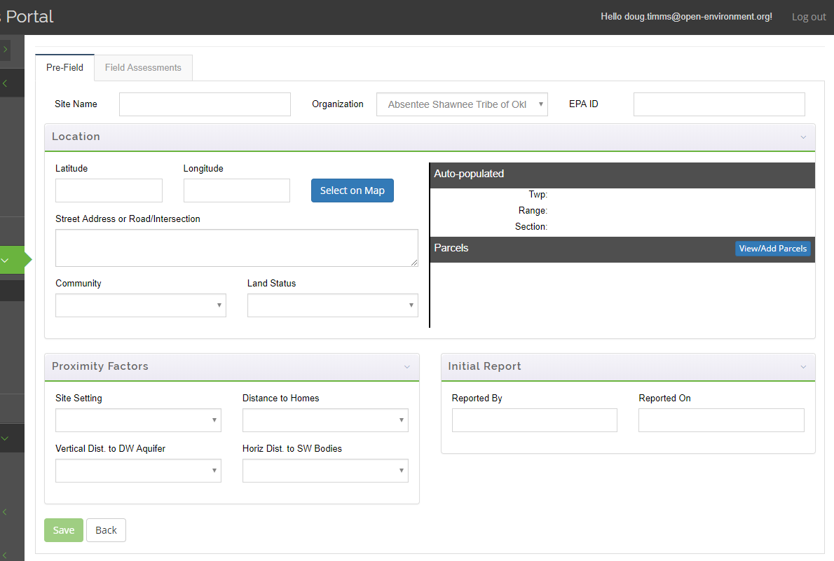

**Edit Dump – Pre-Field Tab**

General site information includes:

* **Site Name**
* **EPA IDs**
* **Location:**
  + You can either type in the latitude/longitude or select from a map
  + **PLSS:** If latitude/longitude for the site are supplied, the page will display the Township/Range/Section of the site’s location when the site record is saved
  + **Parcels:** If a parcel service is available for the dump location, the parcel number, owner, and acreage will also be automatically populated when the site record is saved.
* **Proximity Factors:** In order to accurately calculate a Health Threat Score for the site, these proximity factors must be filled in
* **Initial Report:** indicate who initially reported the dump site

## Assessments

Multiple field assessments can be conducted for a dump site.

### Assessments List

Existing assessments can be accessed either by clicking on the  link on the left menu, or by viewing the details of a site record, and clicking on the  tab.

This will display all assessments that have been conducted, as shown here:

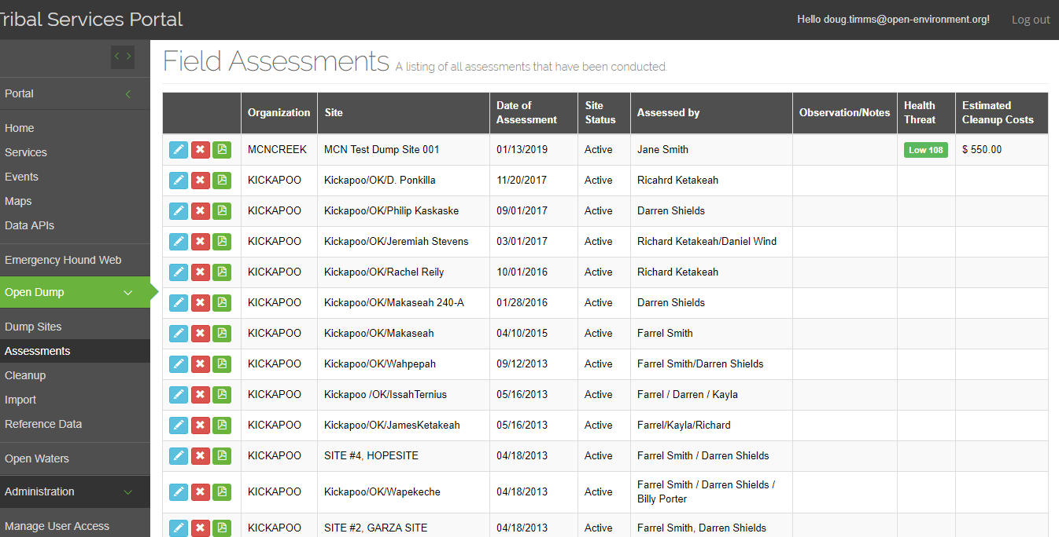

**Edit Dump – View All Assessments**

### Assessment Details

#### General Field Assessment Information

When adding or editing an assessment, you can track the assessment date, who conducted the assessment, assessment type, site status, and notes.

The assessment type can be:

* Initial Assessment
* Annual Review
* Final Review

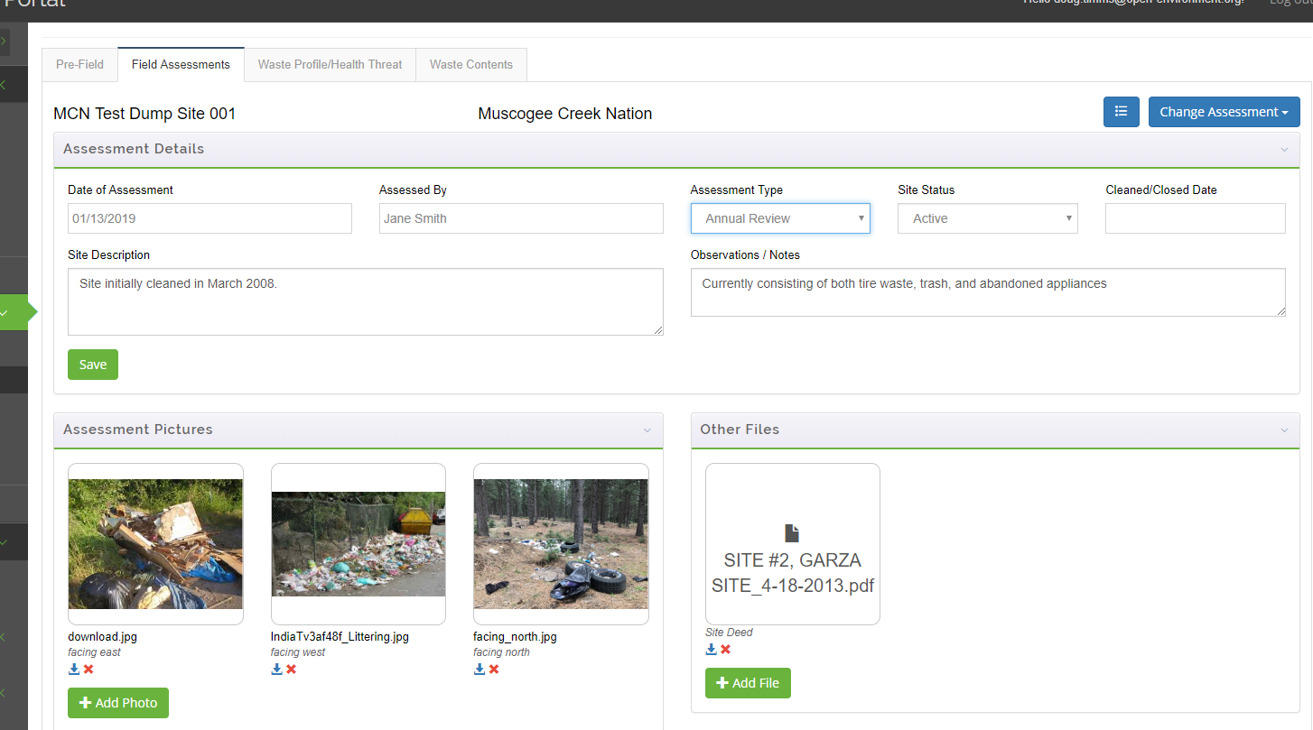

**Edit Dump – Edit or Add New Assessment**

In addition, you can upload one or more photos taken during the assessment, and one or more files associated with the assessment.

When the user is finished, they can click the **Save** button to save the record.

#### Waste Profile

Click on the **Waste Profile/Health Threat** tab to enter in the types of waste at the site. This tab is used to identify the waste profile for the site, based on the findings of a particular assessment.

Note: This is the bulk of information that will be used to generate the **IHS Open Dump Survey Form**.

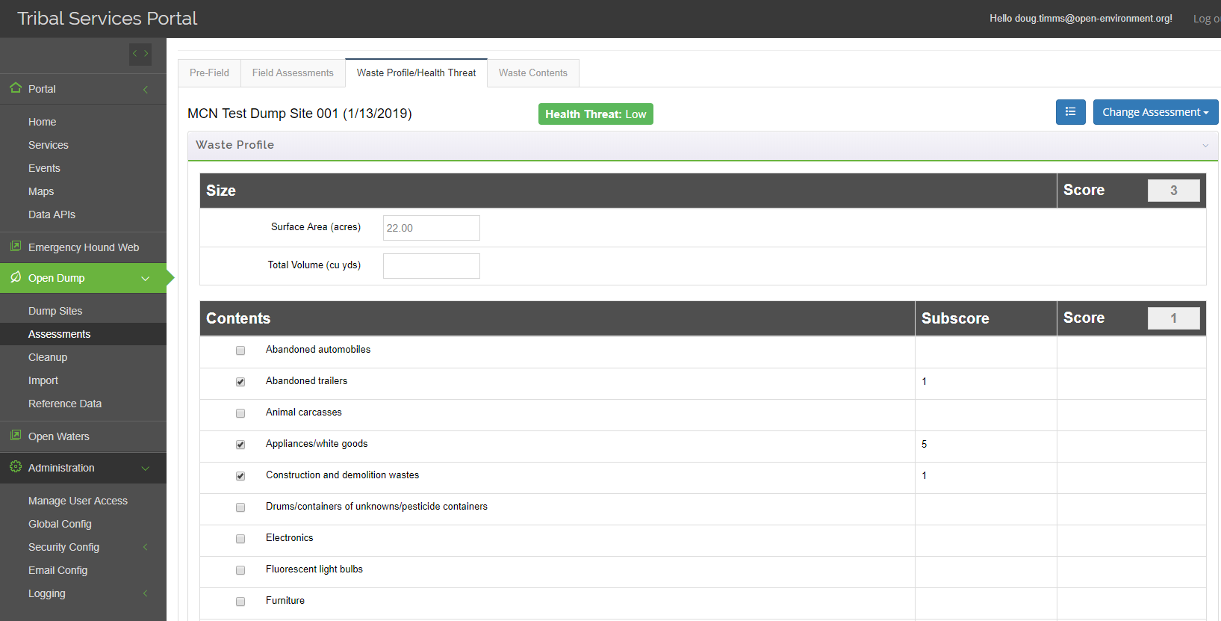 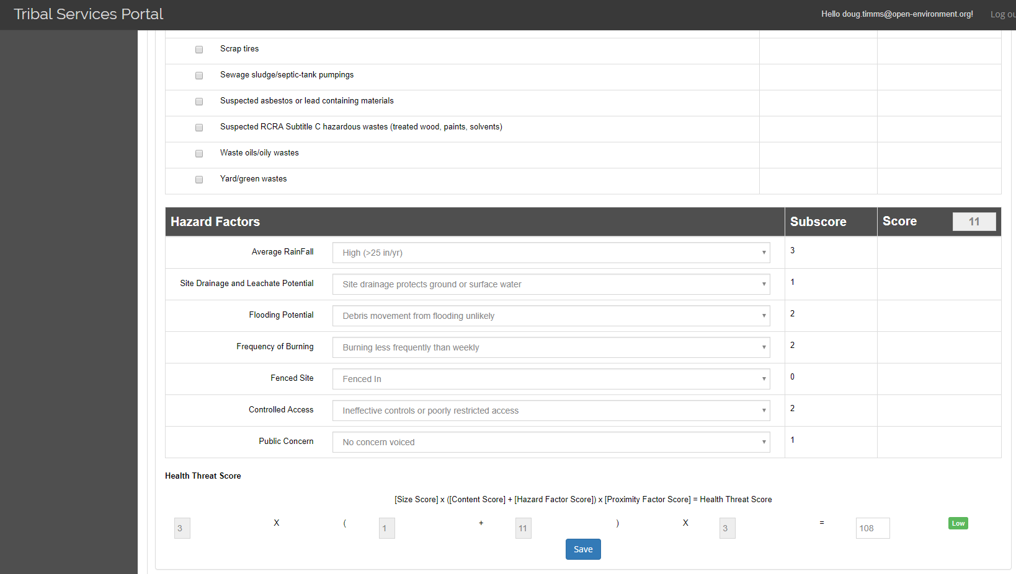

**Edit Dump – Waste Profile / Health Threat**

**Site Size:**

The user will provide first estimate the size of the dump by providing a surface area and total volume.

The system will automatically tally a sub-score based on the provided surface area.

|  |  |
| --- | --- |
| Site Size Characteristic Points | Data field: **Size** |
| 3 | More than 5 acres |
| 2 | 0.5 - 5 acres |
| 1 | Less than 0.5 acres |

**Site Contents:**

The user can then identify the contents for the site, which is done by clicking checkboxes for the types of waste are found at the site.

When the user selects a waste type, a corresponding subscore will be automatically displayed, according to the following table:

| Observed contents | Sub-score |
| --- | --- |
| Abandoned automobiles | 5 |
| Abandoned trailers | 1 |
| Animal carcasses | 5 |
| Appliances/white goods | 5 |
| Construction and demolition wastes | 1 |
| Drums/containers of unknowns/pesticide containers | 10 |
| Electronics | 5 |
| Fluorescent light bulbs | 5 |
| Furniture | 1 |
| Lead acid batteries | 10 |
| Medical wastes | 10 |
| Meth-lab wastes | 10 |
| Municipal solid waste | 5 |
| Scrap tires | 1 |
| Sewage sludge/septic-tank pumpings | 5 |
| Suspected asbestos or lead containing materials | 10 |
| Suspected RCRA Subtitle C hazardous wastes (treated wood, paints, solvents) | 10 |
| Waste oils/oily wastes | 5 |
| Yard/green wastes | 1 |

A total site content score is then also automatically calculated by adding the points for the following parameters:

|  |  |
| --- | --- |
| Points | Data field: **Contents** |
| 8 | Contents hazard factor sub-score is greater than or equal to 25 |
| 4 | Contents hazard factor sub-score is greater than 10 and less than 25 |
| 1 | Contents hazard factor sub-score is less than or equal to 10 |

**Hazard Factors:**

The user can then answer questions related to the hazard factors of the site.

Based on the answers to the questions, the following subscores will be automatically displayed according to the tables below:

|  |  |
| --- | --- |
| Points | Data field: **Rainfall** |
| 3 | High > 25 inches per year |
| 2 | Medium = 10 – 25 inches per year |
| 1 | Low < 10 inches per year |

|  |  |
| --- | --- |
| Points | Data field: **Site draining and leachate potential** |
| 6 | Site drainage increases ground or surface water contamination |
| 3 | Limited ponding, drainage effects largely neutral |
| 1 | Site drainage protects ground or surface water |

|  |  |
| --- | --- |
| Points | Data field: **Flooding potential** |
| 3 | Debris movement from flooding likely |
| 2 | Debris movement from flooding unlikely |
| 1 | No potential for flooding |

|  |  |
| --- | --- |
| Points | Data field: **Frequency of burning** |
| 4 | Burning weekly or more frequently |
| 2 | Burning less frequently than weekly |
| 1 | Burning does not occur |

|  |  |
| --- | --- |
| Points | Data field: **Controlled Access** |
| 4 | Unrestricted access |
| 2 | Ineffective controls or poorly restricted access |
| 1 | Effectively controlled access |

|  |  |
| --- | --- |
| Points | Data field: **Public concern** |
| 3 | Concern frequently voiced by public |
| 2 | Little concern voiced by public |
| 1 | No concern voiced |

**Overall Health Threat Score:**

Finally, at the bottom of the page will be displayed the calculation of the overall Health Threat Score for the site. This uses the following formula:

[Size Score] x ([Content Score] + [Hazard Factor Score]) x [Proximity Factor Score] = Health Threat Score

Based on the calculated Health Threat Score, a hazard categorization will also be displayed, according to the following table:

|  |  |  |
| --- | --- | --- |
| Health threat score | = | site score x hazard score x proximity score |
| 0 - 250 | = | Low |
| 251 - 400 | = | Moderate |
| 401 - 1,488 | = | High |

### Waste Contents

This tab is used to support the estimation site cleanup costs (next section), based on the waste profile provided on the previous tab, plus additional input information supplied on this tab. First, the user is prompted to enter in the amounts of waste, for each type of waste that was selected on the previous tab.

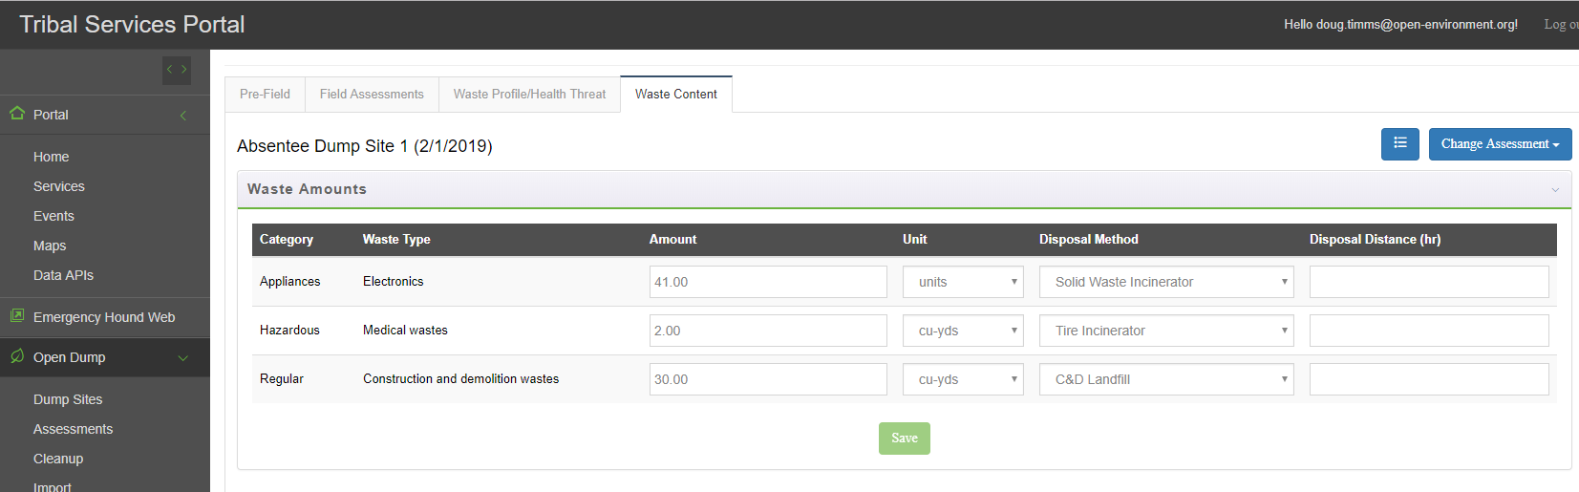

**Edit Dump – Waste Contents**

For each waste type, the user will enter in an amount, unit, disposal method, and disposal distance.

### Open Dump Survey Form

When viewing the list of assessments, click on the report button () to generate an IHS Open Dump Survey Form for that particular assessment. An example snippet of the report is shown here, automatically generated from the system:

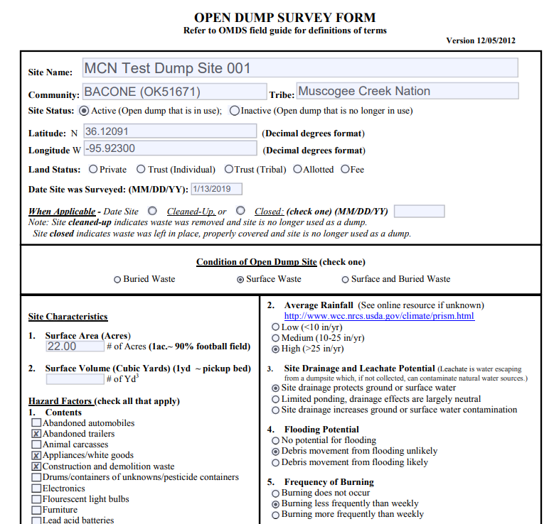

## Cleanup Estimation Modeling and Actual Cleanup Projects

The system supports the management of two types of cleanup data:

* **Cleanup Estimation Modeling:** Based on the waste contents recorded for a particular site assessment, the system can estimate the expected cleanup costs for the site.
* **Actual Cleanup Projects:** The system can capture the dates, photos, and cleanup costs that a tribe incurs as part of implementing a cleanup project.

Both **Cleanup Estimates** and **Actual Cleanup Projects** are managed by navigating to the Open Dump 🡪 Cleanup menu option, as shown here:

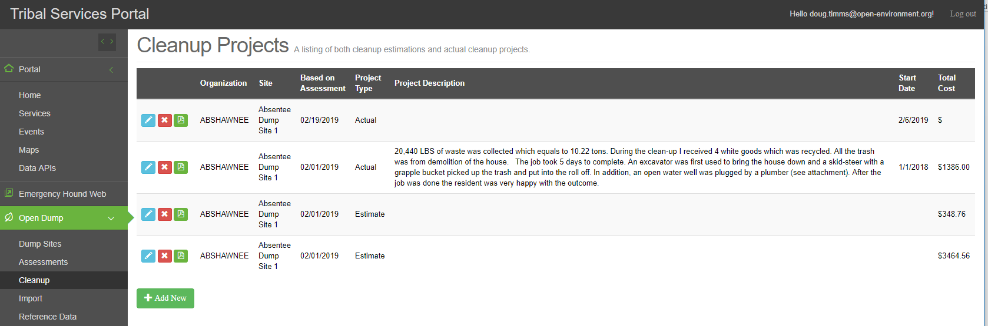

**Listing of Cleanup Estimates and Actual Cleanup Projects**

You can distinguish **Cleanup Estimates** from **Actual Cleanup Projects** by looking at the “Project Type” column.

### Cleanup Estimate Modeling

***Note:*** *In order to properly perform clean estimation, you must first have an assessment conducted at a dump site and have the waste contents for the dump entered. (See section 2.3.2 and 2.3.3).*

To start a cleanup estimation model, go to the Open Dump 🡪 Cleanup menu and click the **Add New** button. On the pop-up screen, select “Estimate” and the assessment on which this estimation will be based, as shown here:

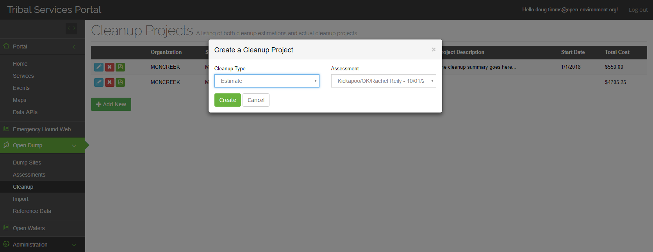

**Create Cleanup Estimate**

A cleanup estimate will be calculated, which will be based on the waste present, transportation, and disposal costs. No costs will automatically be estimated for Site Restoration or Surveillance, but they can be added manually.

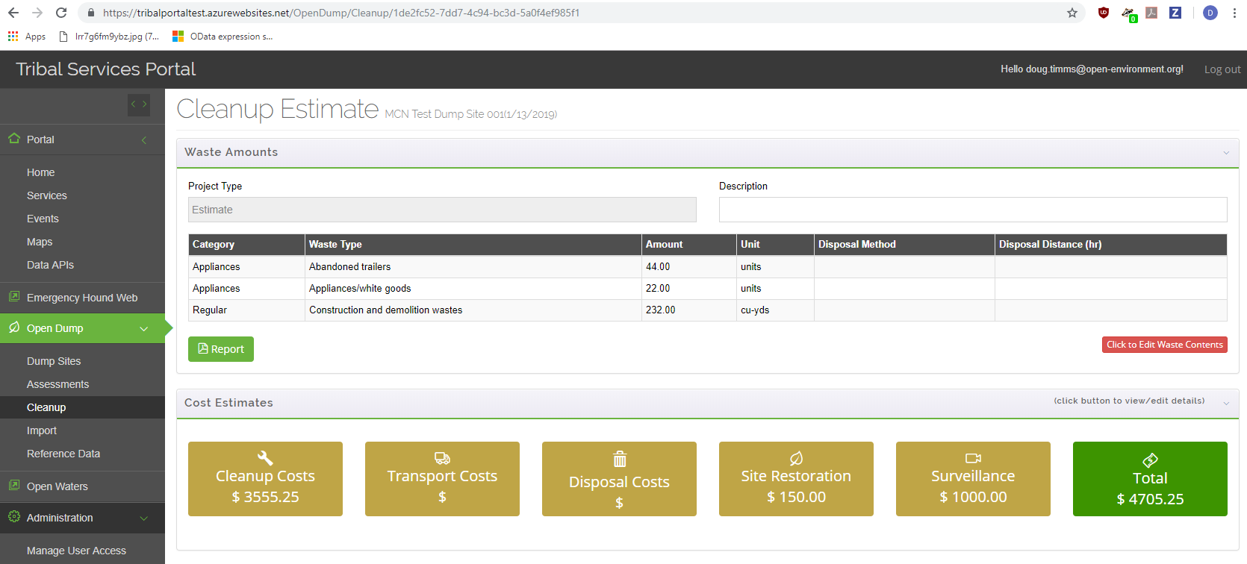

Click to edit

**Cleanup Estimate Details**

You can click on any of the tan shaded boxes to view/edit the details:

#### Cleanup Costs

Cleanup costs will be calculated automatically based on the content amounts in the dump.

Reference data for each tribe will indicate the number of personnel and equipment typically used for site cleanup, as well as their processing rate and cost rate. These reference data will be maintained for each “category” of waste types. Categories include “Regular”, “Appliances”, and “Tires”, although the database supports the creation of different waste type categories and cost factors.

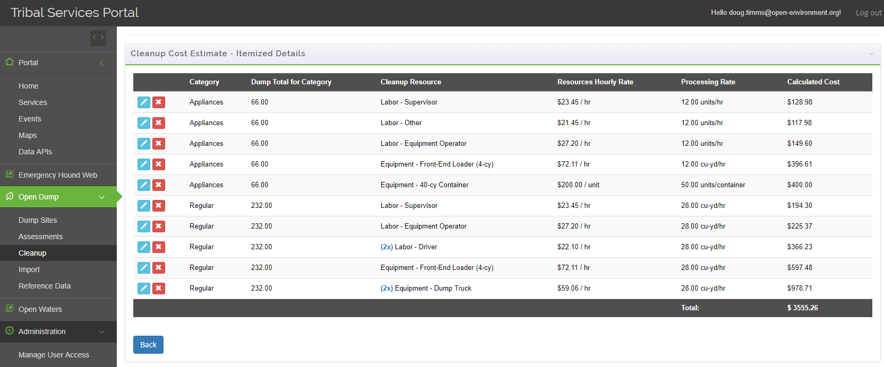

**Cleanup Detailed Cost Items**

The cleanup cost worksheet allows users to override the default calculations.

#### Transportation Costs

Transport costs will be automatically calculated for each waste type supplied for the site.

* First, the number of loads will be calculated for each disposal type identified at the site. The number of loads is calculated by dividing the total waste by the amount of waste that can be handled per load.
* Then for each disposal type, the number of loads is multiple by the number of hours it takes to transport to the disposal site, and then multiplied by the hourly labor + hourly equipment costs.
* Formula looks like this:

Cost = NumLoads x HoursPerLoad x (HourlyLaborRate + HourlyEquipmentRate)

The worksheet will allow the user to manually override the automatic transport cost calculation.

#### Disposal Costs

Like Transport costs, disposal costs are based on the different disposal methods. Disposal cost will be automatically calculated by the system.

* For each disposal type, the amount of estimated waste is first tallied.
* Then for each disposal type the waste amount is multiplied by the cost per unit.
* These subtotals will then be summed to calculate the total disposal costs.

The worksheet will allow the user to manually override the automatic disposal cost calculation.

#### Site Restoration

Unlike the previous sections, site restoration costs will not be automatically calculated. Instead, a worksheet will be available for the user to supply the different line items for typical site restoration activities and manually supply the estimated cost for each line item, as shown here:

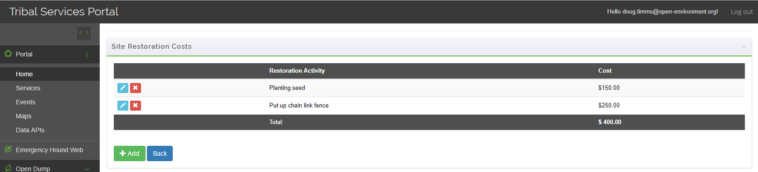

**Site Restoration Worksheet**

The system will tally the total Site Restoration costs from the individual components.

#### Surveillance

Site surveillance costs are also manually entered by the user. A worksheet allows the user to supply the different line items for typical site surveillance costs and manually supply the estimated cost for each line item.

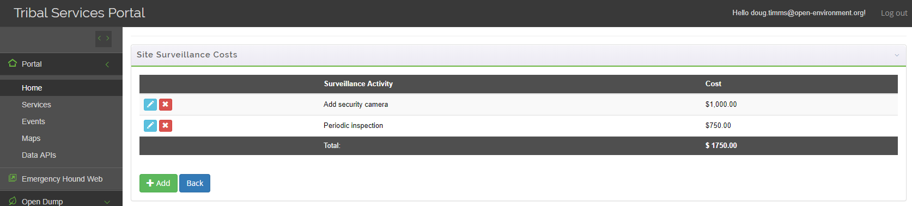

**Surveillance Worksheet**

The system will tally the total Site surveillance costs from the individual components.

#### Cleanup Estimate Report

After a cleanup estimate model has been run, you can generate an **Illegal Dumping Economic Assessment (IDEA) Model** report, by clicking on the  button on the Cleanup Estimate main page. The report will summarize all information provided for the cost estimate, as shown here:

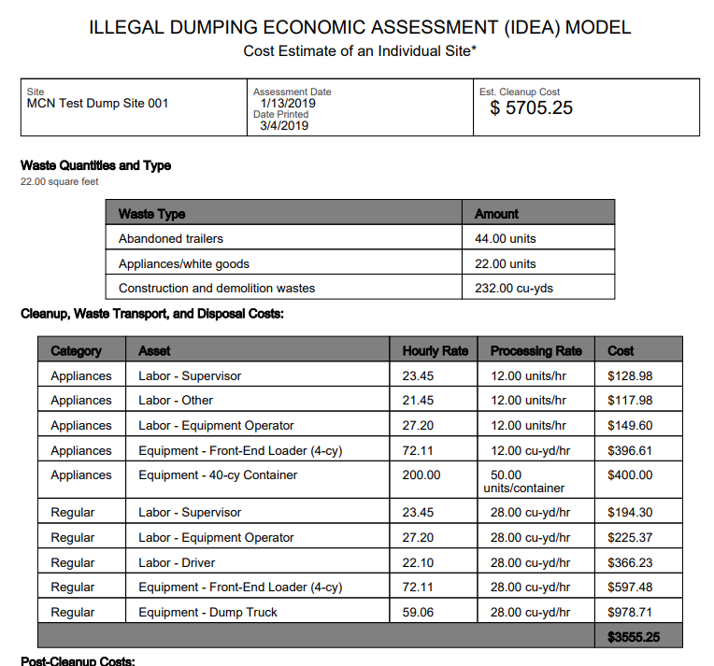

**IDEA Model Report**

### Actual Cleanup Projects

***Note:*** *This is called an “Actual” Cleanup Project, to distinguish it from a cleanup estimate. An actual cleanup project has a begin and end date, and real costs.*

To track a cleanup project, go to the Open Dump 🡪 Cleanup menu and click the **Add New** button. On the pop-up screen, select “Actual” and the assessment on which this cleanup project will be based, as shown here:

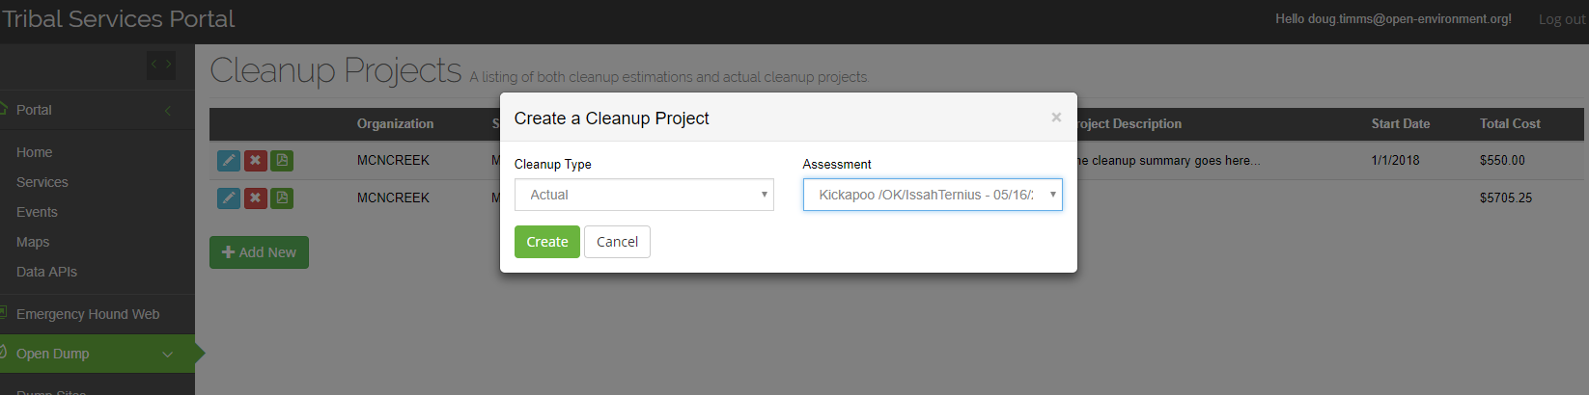

**Creating an Actual Cleanup Project**

When creating a cleanup project, you can specify the start and completion date, person responsible for cleanup, and cleanup summary actions. In addition, you can provide a listing of itemized costs incurred for this cleanup project.

Finally, you can upload before and after pictures, to demonstrate progress made on the cleanup project, as shown here:

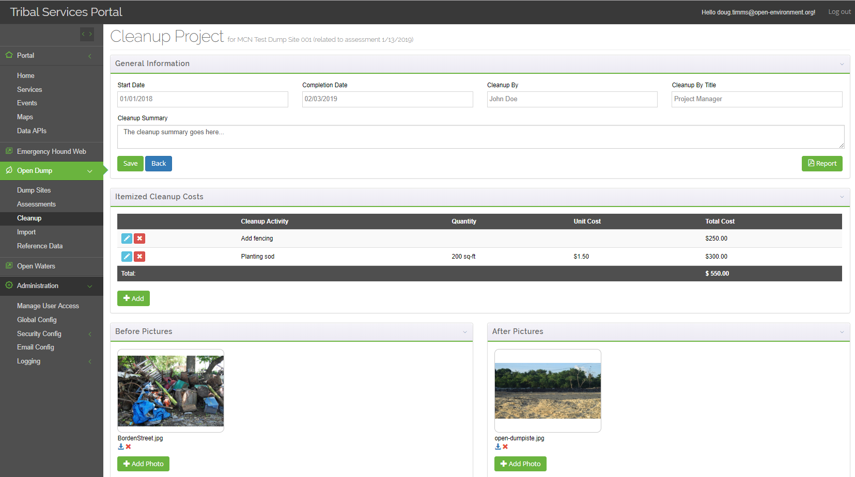

**Cleanup Project Details**

**Actual Cleanup Report:** by clicking on the  button on this page, you can generate a report which summarizes the activities of the cleanup project, as shown here:

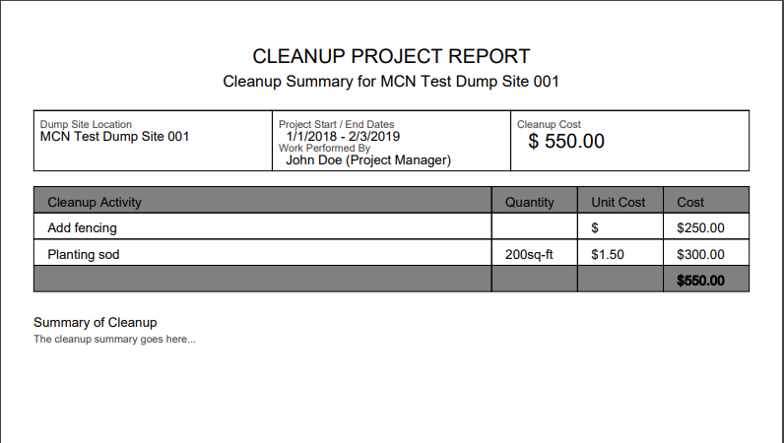

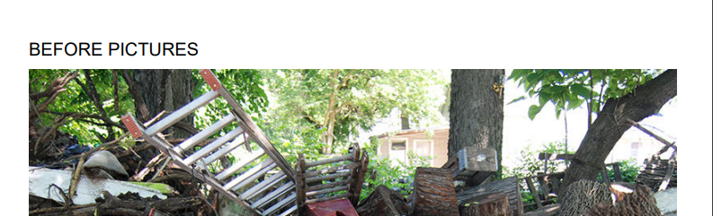



## Importing Data

Tribes can bulk import a listing of open dump records into the system. Navigate to the Open Dump 🡪 Import menu, as shown here:

To import dump sites you must use the pre-defined import template defined by the system. You can click on the **Download Import Templates** button to download an Excel file with the import template. Fill out this template, and then copy the data, including the column headers, as shown here:

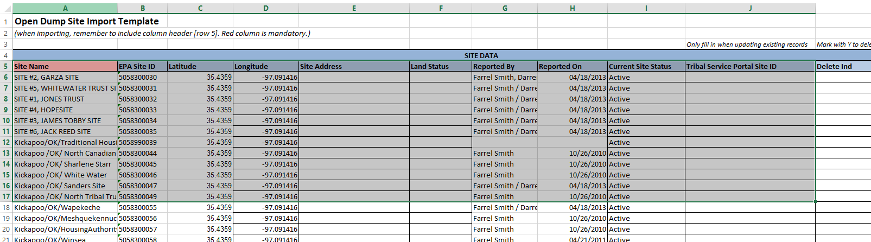

**Import Sites: Copying Data From Excel**

And then paste the data into the large textbox on the import screen, as shown here:

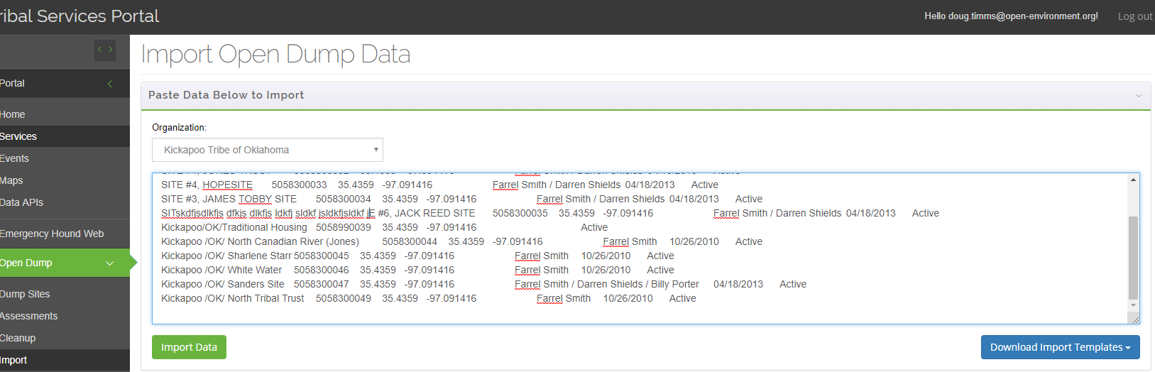

**Import Sites: Pasting Data from Excel**

Then click the **Import Data** button. If there are no errors, your sites will be imported automatically. However, if any errors are detected the entire import batch will not be imported and a validation summary will be displayed.

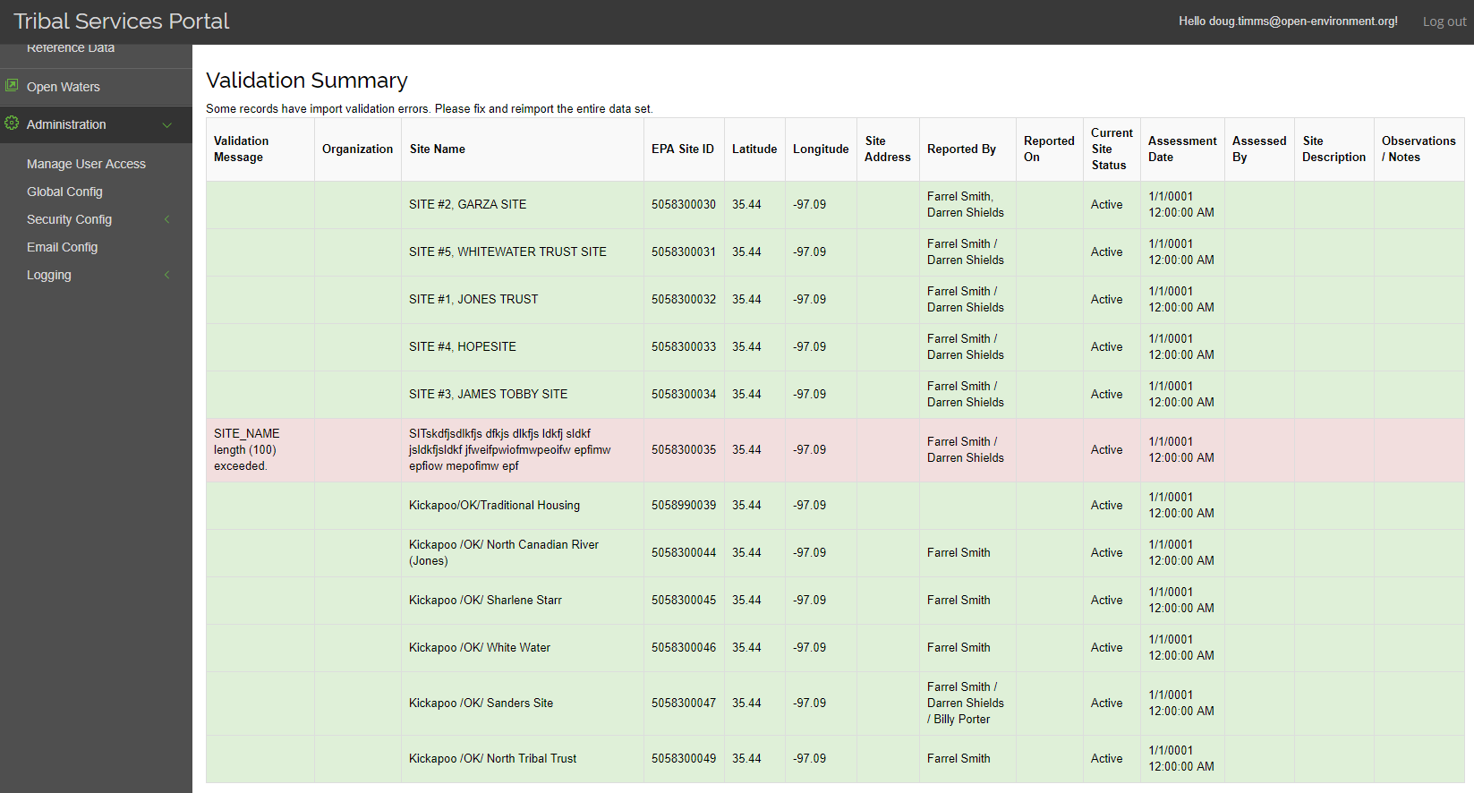

**Import Sites: Validation Summary**

Any records that have failed validation will be shown in red. You must correct the error in Excel and reimport the entire batch.

# Administering the Open Dump Module

## Approving Access Requests

By default a user will not have access to the Open Dump Module in the Tribal Services Portal. When a user requests access to the Open Dump module, an administrator will receive an email. To approve or reject an access request, follow these steps:

1. Navigate to the Administration 🡪 Security Config 🡪 Users screen and click on the Blue edit icon, as shown here:

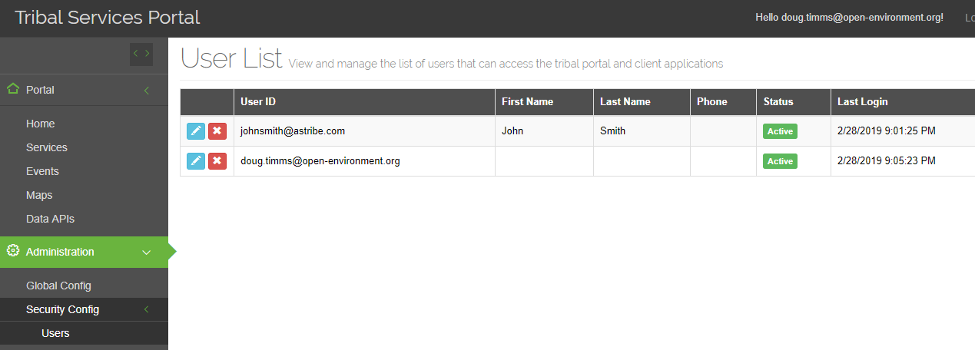

1. At the bottom of the **User Details** page will be an **Organization Access** section listing of the Organizations (i.e. Tribes) that the User account is associated with.

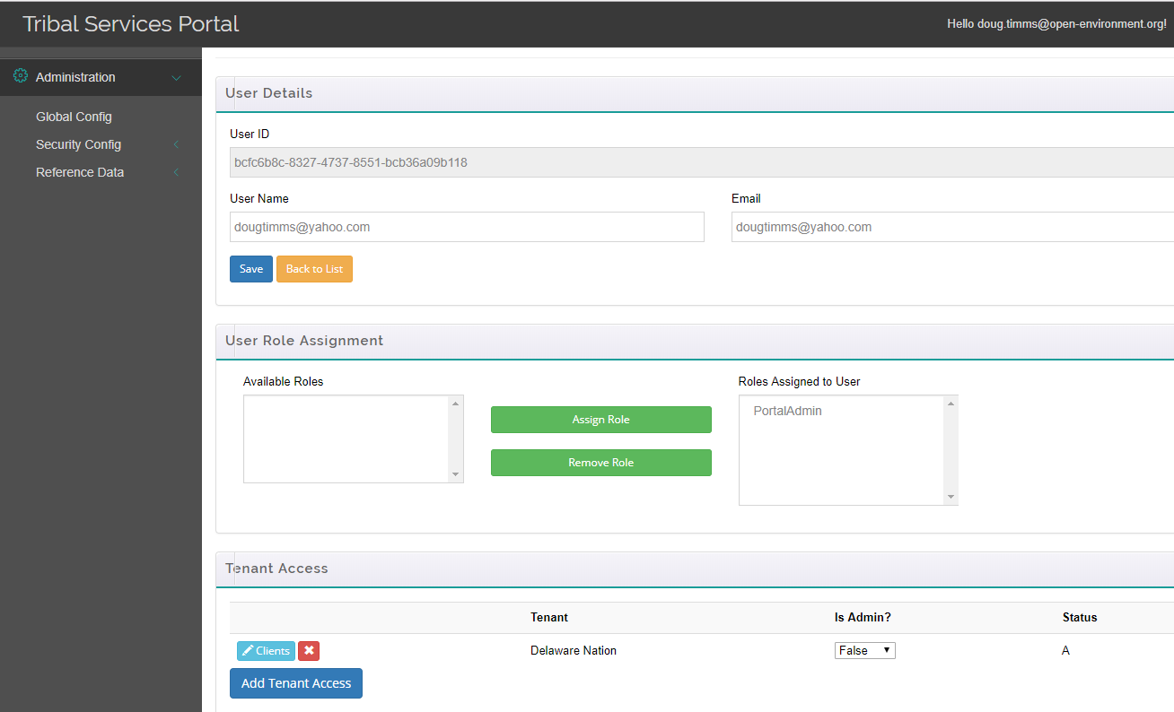

1. Click the **Clients** button for the tribe your wish to manage rights for. This will display the different client applications that are available for the user for the particular tribe, as shown here:

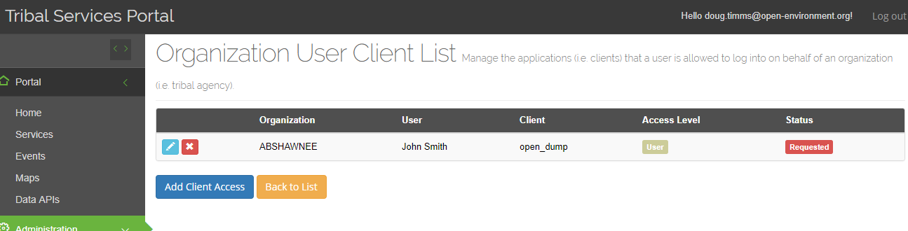

1. If you see an entry for “open_dump” then click the blue edit icon to edit that record, otherwise click the **Add Client Access** button to add new access rights.
2. To **approve** the user, change the drop-down from Requested/Rejected to **Active:**

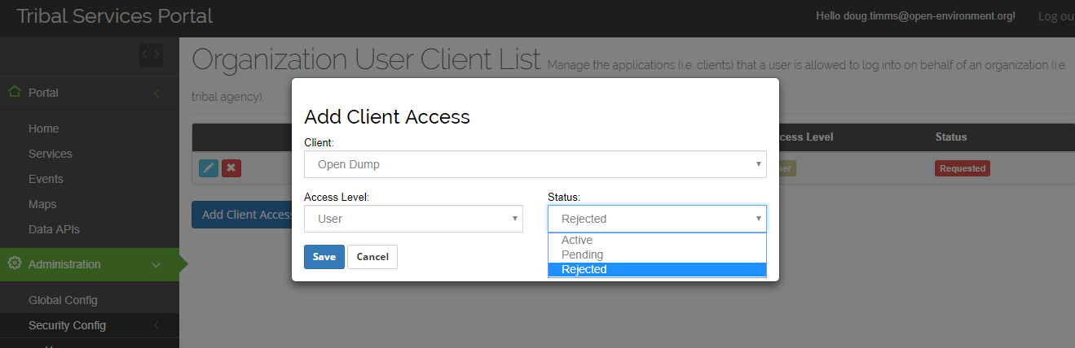

## Reference Data

Managing Open Dump data relies on a variety of reference data. To manage Open Dump reference data, navigate to the Open Dump 🡪 Reference Data screen.

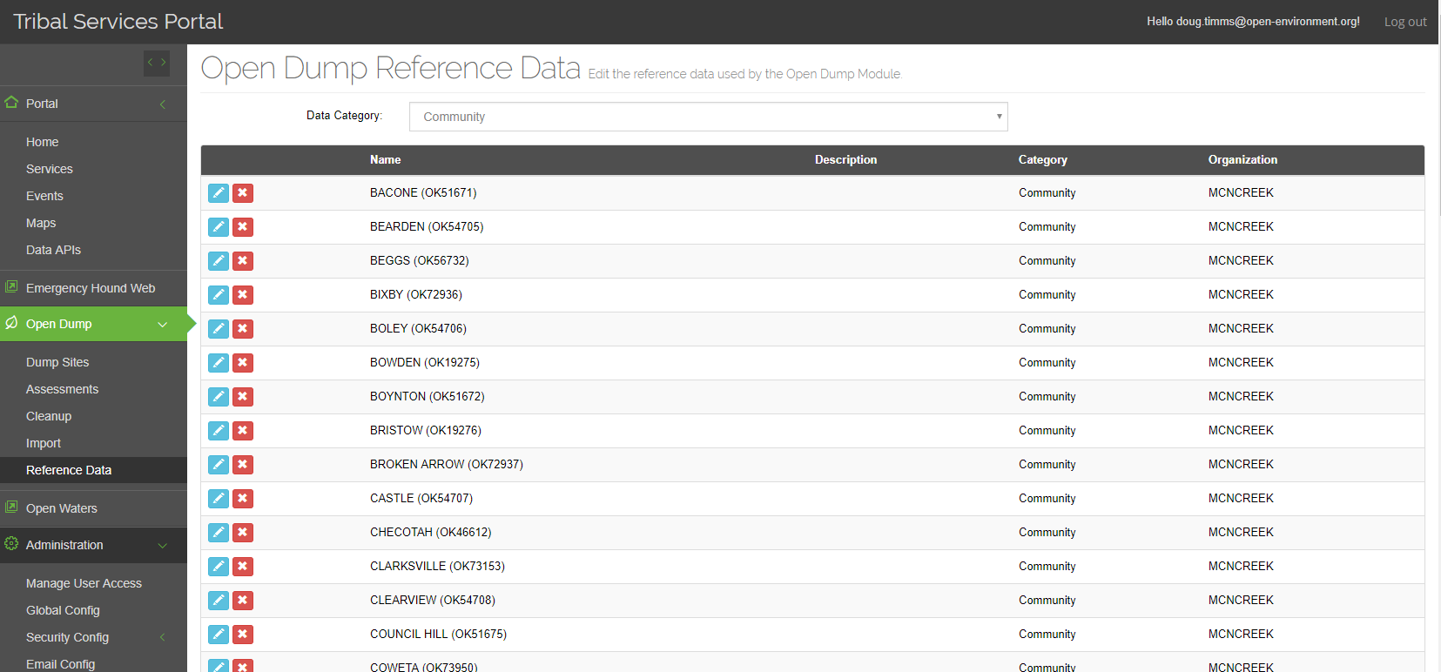

The system allows the user to maintain the following reference data:

* **Assessment Type**
* **Community** (this reference data is tribe specific)
* **Site Setting**
* **Cleanup Assets** (e.g. the various types of equipment and labor categories used during site cleanup such as “Equipment-Dump Truck”)
* **Cleanup Cost Rates** – this includes the various hourly rates or per/load rates used for each cleanup asset (e.g. Equipment Operator hourly rate). Global defaults are included in this reference data, as well as the ability to store tribe-specific overrides to the global defaults.
* **Disposal Types**
* **Site Restoration Types**